Sometimes we want to examine the distribution of a single categorical variable in a population. The chi-square goodness-of-fit test allows us to determine whether a hypothesized distribution seems valid.
We can decide whether the distribution of a categorical variable differs for two or more populations or treatments using a chi-square test for homogeneity. We will often organize our data in a two-way table.
It is also possible to use the information in a two-way table to study the relationship between two categorical variables. The chi-square test for independence allows us to determine if there is convincing evidence of an association between the variables in the population at large.
Mars Incorporated makes the milk chocolate candies; M&Ms. Here's what the company's Consumer Affairs Department says about the color distribution of its M&Ms Milk Chocolate Candies. On average, the new mix of colors will contain 13% red, 13% brown, 14% yellow, 16% green, 20% orange, and 24% blue.
We purchase a bag of M&Ms to test their claim. We find the following number information:
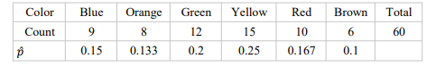
Because the company claims that 24% of all M&Ms are blue, we might believe that something fishy is going on.
We could use the one-sample z test for a proportion to test the hypotheses ;
Ho: ρ = 0.24 and
H1: ρ ≠ 0.24
Where ρ is the true population proportion of blue M&Ms.
We could then perform additional significance tests for each of the remaining colors. Performing a one-sample z test for each proportion would be pretty inefficient and would lead to the problem of multiple comparisons.
Performing one-sample z tests for each color wouldn't tell us how likely it is to get a random sample of 60 candies with a color distribution that differs as much from the one claimed by the company as this bag does (taking all the colors into consideration at one time).
For that, we need a new kind of significance test, called a chi-square goodness of fit test.
The null hypothesis in a chi-square goodness of fit test should state a claim about the distribution of a single categorical variable in the population of interest.
The alternative hypothesis in a chi-square goodness of fit test is that the categorical variable does not have the specified distribution.
We can also write the hypotheses in symbols as;
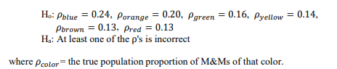
The idea of the chi-square goodness of fit test is this: we compare the observed counts from our sample with the counts that would be expected in Ho is true.
The more the observed counts differ from the expected counts, the more evidence we have against the null hypothesis.
Assuming that the color distribution stated by Mars Inc. is true, 24% of all M&Ms produced are blue. For a random sample of 60 candies, the average number of blue M&Ms should be (0.24)(60) = 14.40. This is our expected count of blue M&Ms. Using this same method, we can find the expected counts for the other color categories:
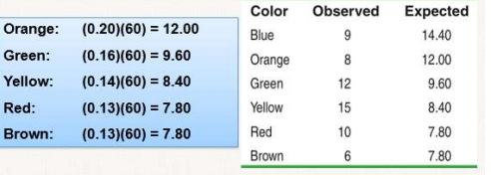
To see if the data give convincing evidence against the null hypothesis, we compare the observed counts from our sample with the expected counts assuming Ho is true. If the observed counts are far from the expected counts, that's the evidence we were seeking.
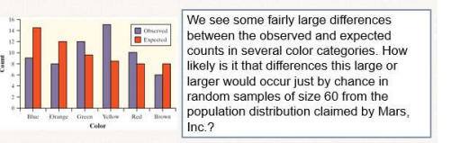
To answer this question, we calculate a statistic that measures how far apart the observed and expected counts are from each other. The statistic we use to make the comparison is the chi-square statistic.
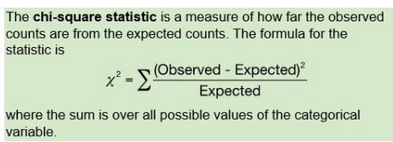
The table shows the observed and expected counts for our sample of 60 M&Ms. Let's calculate the chi-squared statistic.
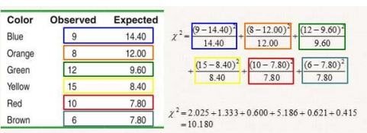
χ 2 is a measure of the distance of the observed counts from the expected counts. Large values of χ 2 are stronger evidence against Ho because they say that the observed counts are far from what we would expect if Ho were true. Small values of χ 2 suggest that the data are consistent with the null hypothesis.
The sampling distribution of the chi-square statistic is not a Normal distribution. It is a right-skewed distribution that allows only positive values because χ 2 can never be negative.
When the expected counts are all at least 5, the sampling distribution of the χ 2 statistic is close to a chi-square distribution with degrees of freedom (df) equal to the number of categories minus 1.
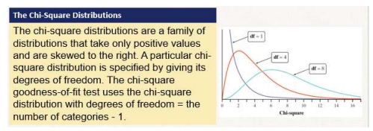
We compute the chi-square statistic for our sample of 60 M&Ms to be χ 2 = 10.180. Because all of the expected counts are at least 5, the χ 2 statistic will follow a chi-square distribution with df = 6 - 1 = 5 reasonably well when Ho is true.
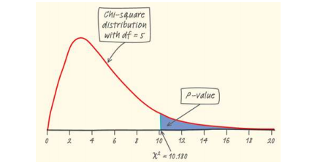
Using our calculator we find the P-value to be 0.0703. Therefore, we would fail to reject Ho if α = 0.05. We don't have sufficient evidence to conclude that the company's claimed color distribution is incorrect.

